Name:  Class: | ____________________________________  SCORE:  / 33  ________________
 | Year 10 Mathematics  2021  Topic – Probability  Full working out MUST be shown to get full marks for each question.
Total Time: | 35 minutes
Weighting: | %
Equipment: | To be provided by the student: Pen, pencil, ruler, scientific calculator, 1 single sided page of A4 notes

Question 1 5 marks (2, 1, 1, 1)
A coin is flipped twice. Draw a tree diagram for the possible outcomes

Determine the probability of obtaining:
i) P (2 heads) = ________________________

ii) P (A tail then a head) = ________________________

ii) A tail and a head in either order ________________________

Question 2 6 marks (1, 1, 1, 1, 2)

A survey of 50 people was carried out to determine what language courses they were taking in high school.
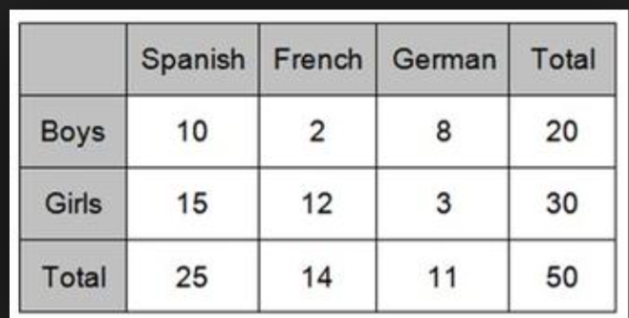

Find the probability that a person chosen at random from this group:

- is male ____________________________
- is a female who studies German ____________________________
- is male OR is someone who studies Spanish _______________________
- studies a language that is not German ____________________________
- is a French student given that the person is male ______________________

Question 3 7 Marks (4, 1, 1, 1)

Of 15 people surveyed to find out if they run or swim for exercise, 6 said they ran, 4 said they swim and 3 said they both run and swim.

- Represent this information in a Venn diagram.

- How many people neither run or swim:

- One of the 15 people is selected at random. Find the probability that they only swim

- Find the probability that a person swims, given that they run

Question 4 6 Marks (3, 1, 1, 1)

A survey of 1200 college students revealed that 450 students have an Instagram account and 900 have a Facebook account. 300 have an account on both.

- Represent this information in a Venn diagram or two-way table.

- If a student is chosen at random, find the probability that the student has :

- No profile on either. _______________________________

- Only a Facebook account _______________________________

- An account on either but not both _______________________________

- A Facebook account, given they have an Instagram account ______________________________

Question 5 7 Marks (3, 1, 1, 2)

A bag contains 3 blue lollies and 2 red lollies. A lolly is taken from the bag and its colour is noted. It is then eaten. A second lolly is then taken from the bag, its colour is noted and then it is eaten.
a) Draw a tree diagram to show all the possible outcomes from this experiment:

b) Find the probability of randomly selecting:
i) a blue lolly and a red lolly in either order ___________________________
ii) two blue lollies ____________________________
ii) at least one red lolly ____________________________

Question 6 2 Marks

A normal coin is tossed and lands on heads 3 times in a row. What is the chance of the coin landing on heads on the next toss? Why?

